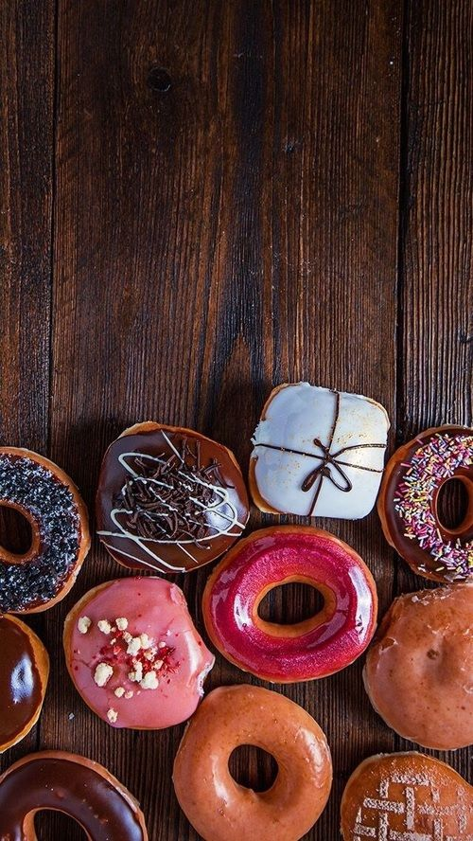

**CAKE**

**Baker**

DEVELOPER GUIDE

**PROJECT**: **THE CAKE SHOP**

**GROUP MEMBERS:**

|  |  |
| --- | --- |
| **GROUP MEMBER** | **ENROLLMENT.NO** |
| **Muhammad Taha Arif** | **STUDENT 1106210** |
| **Ahsan Saleem** | **STUDENT 1104801** |
| **Mahnoor Sadiq** | **STUDENT 1105265** |
| **Khizer Imtiaz** | **STUDENT 1104802** |

**FACULTY:** MISS AATIKA LIAQUAT

**BATCH CODE:** 1805C1

**CURRICULUM:** 6673

**SEMESTER:** HDSE-II



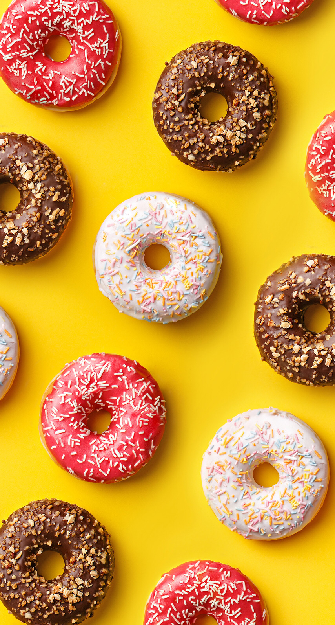

**CHAPTER 1**

**HOME PAGE**

**HEADER**

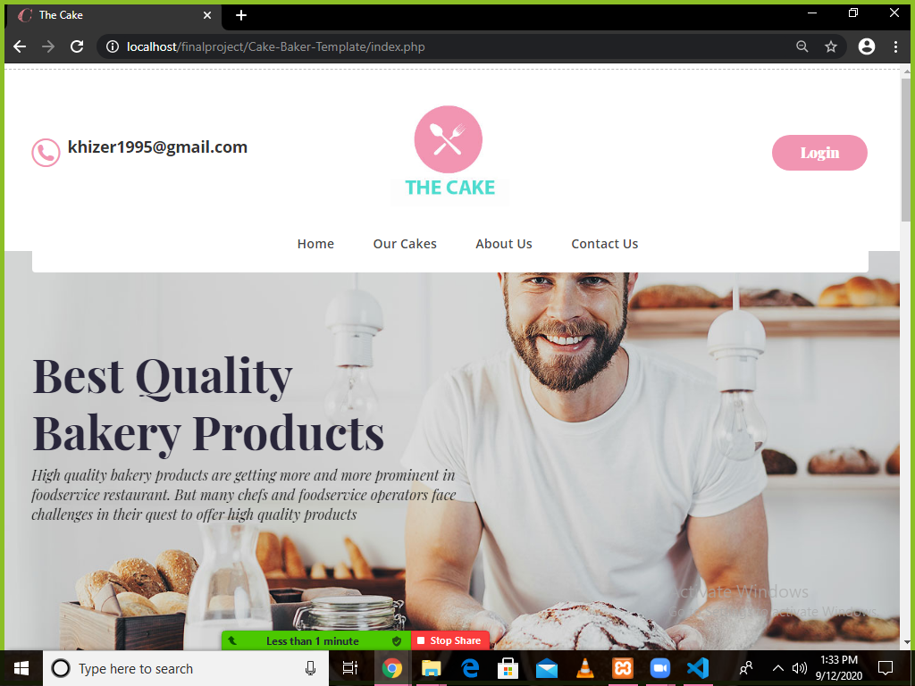

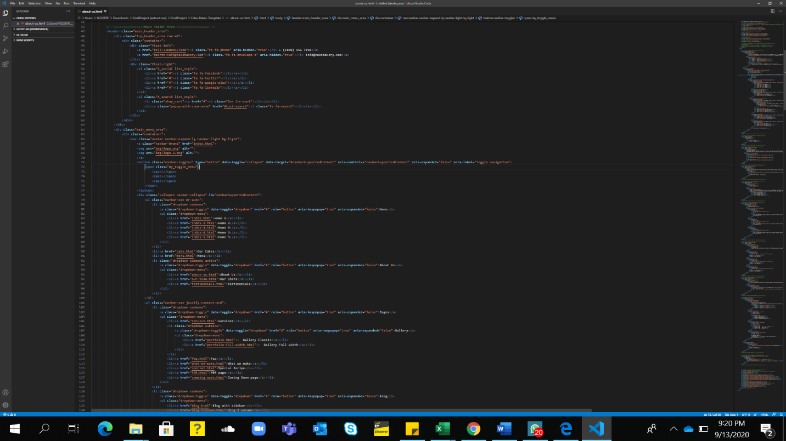

**FOOTER**

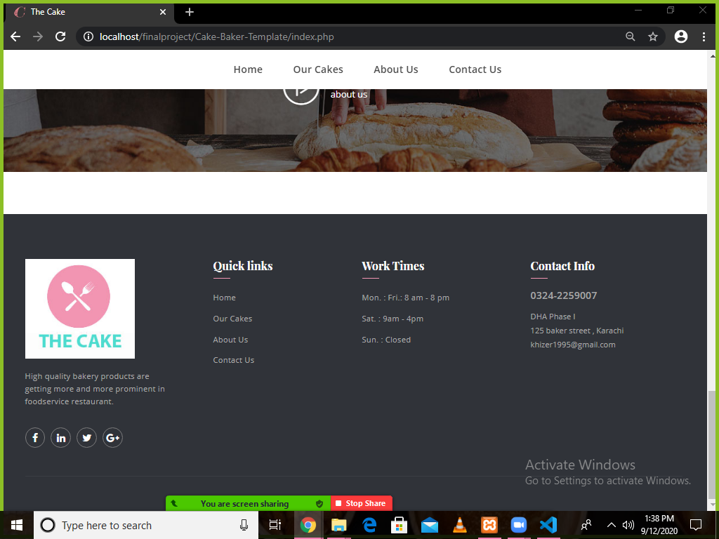

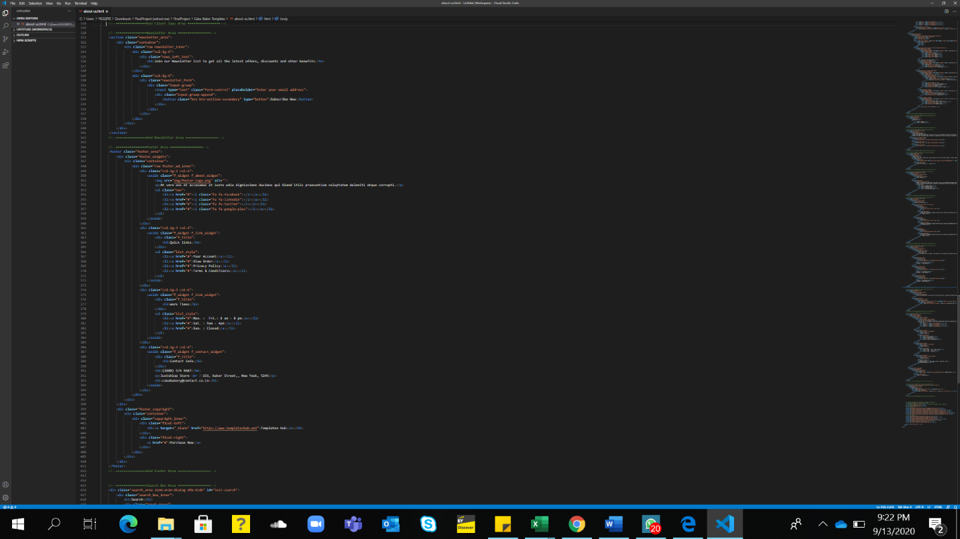



**CHAPTER 2**

**CATEGORY PAGE**

**CATEGORY PAGE**

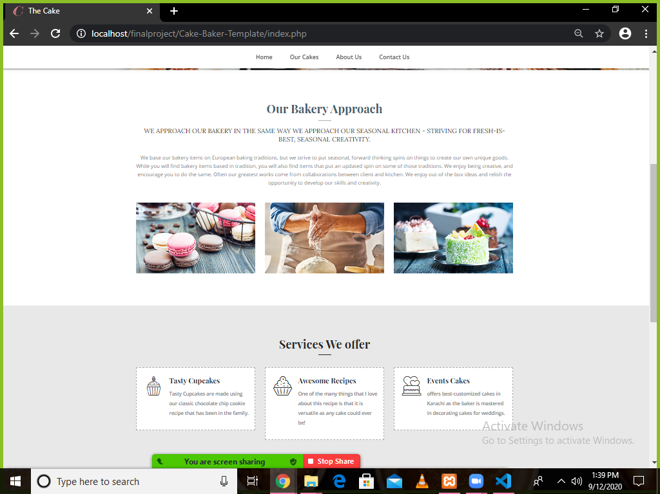

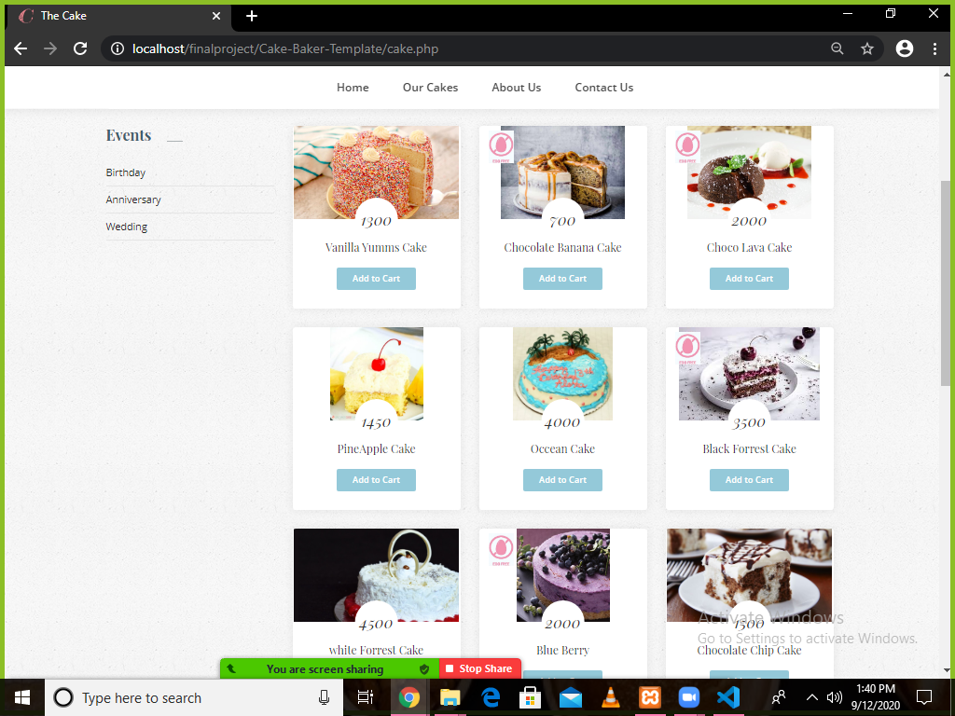

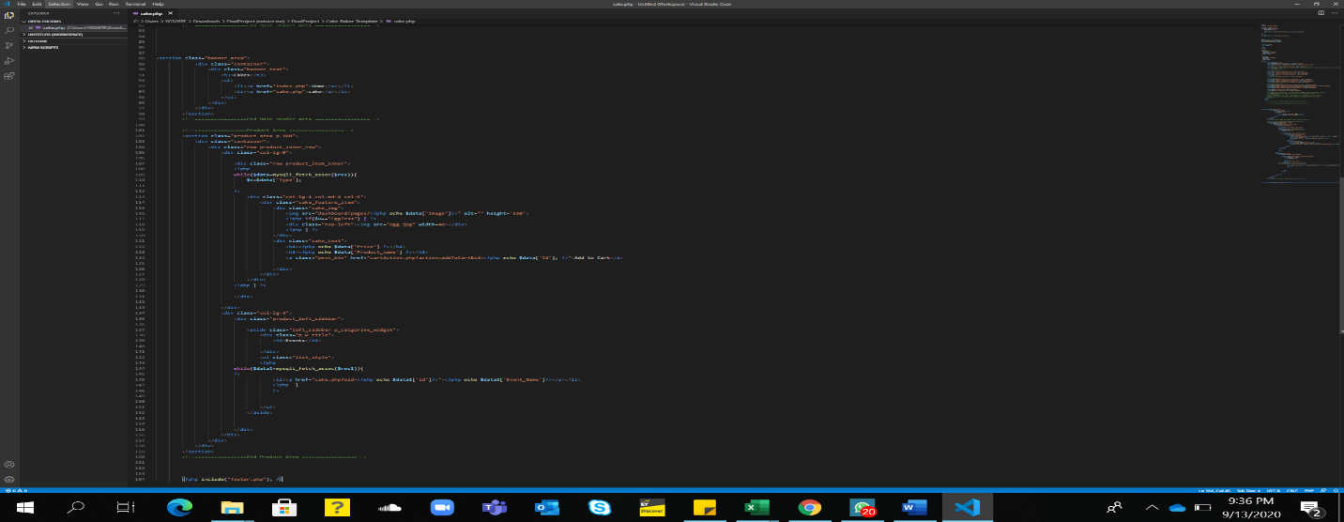



**CHAPTER 3**

**CONTACT US & ABOUT US**

**ABOUT US PAGE**

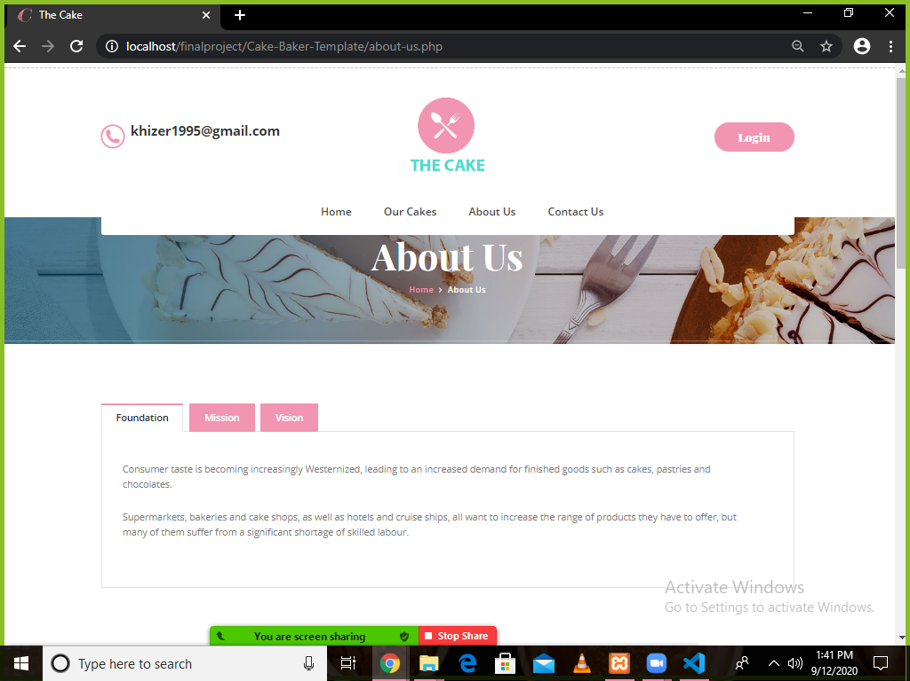

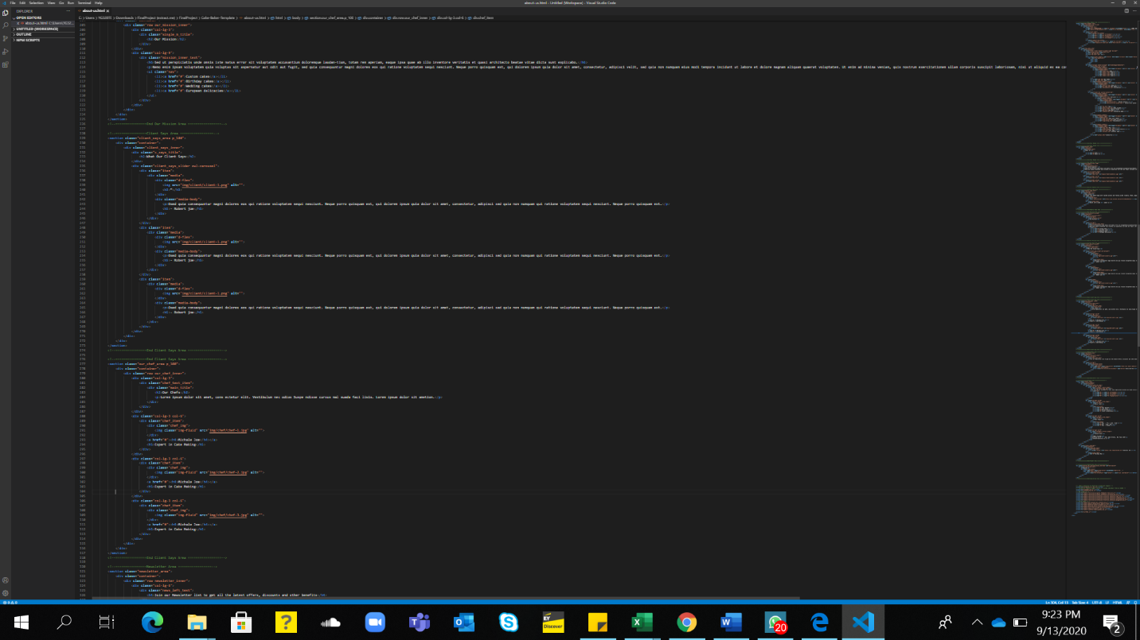

**CONTACT US PAGE**

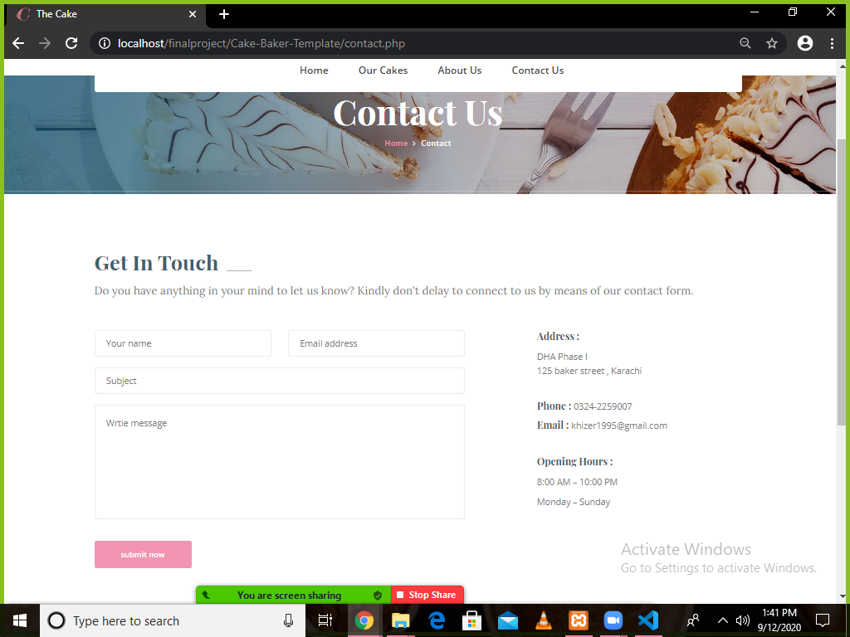

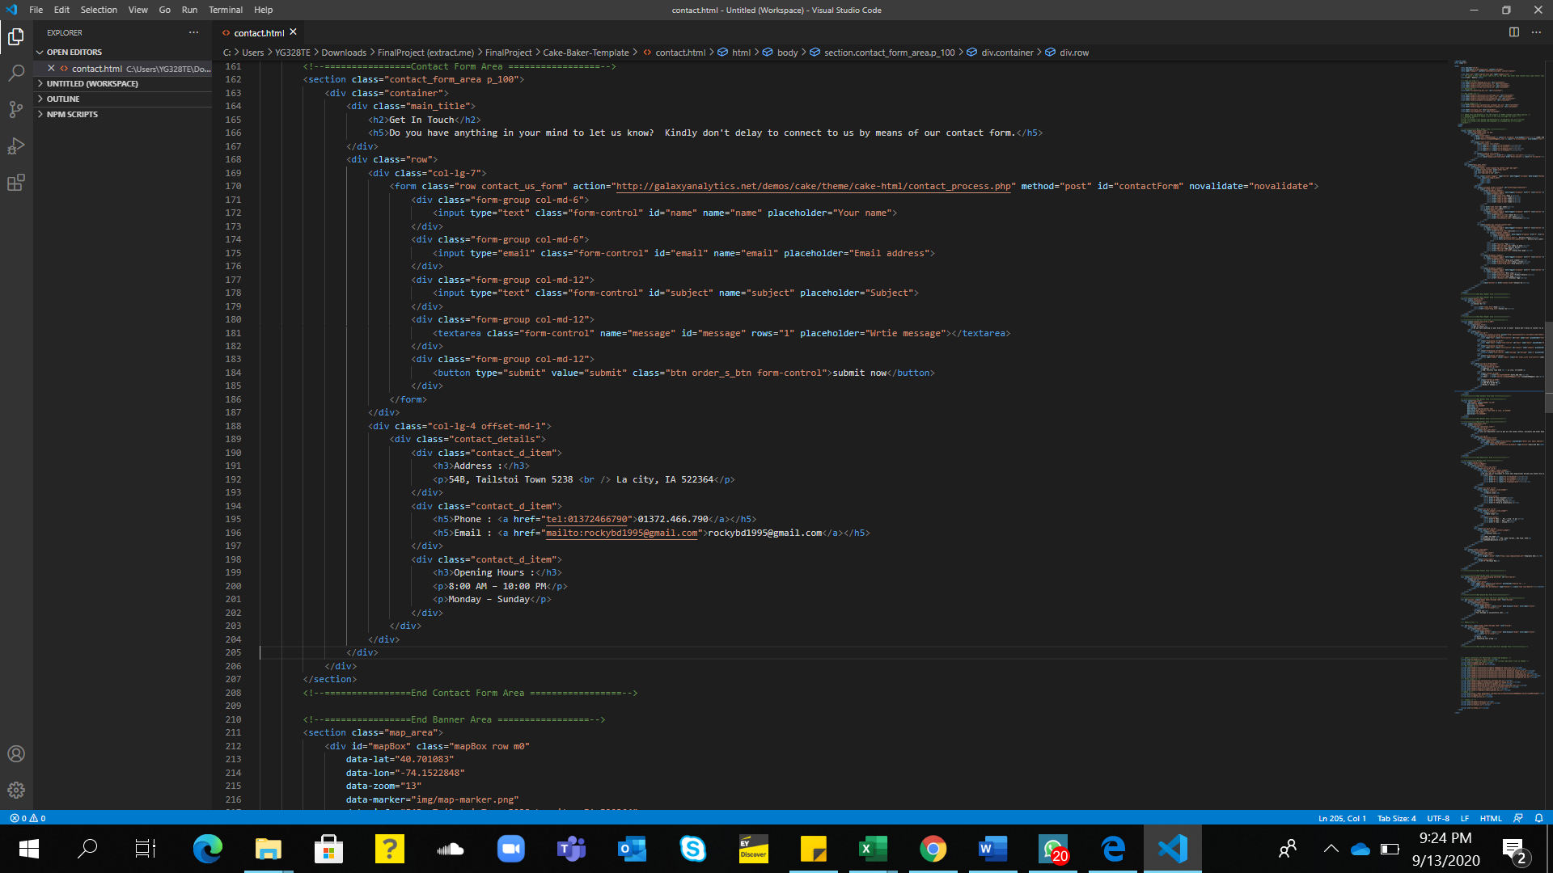



**CHAPTER 4**

**LOGIN & SIGN UP PAGE**

**LOGIN PAGE**

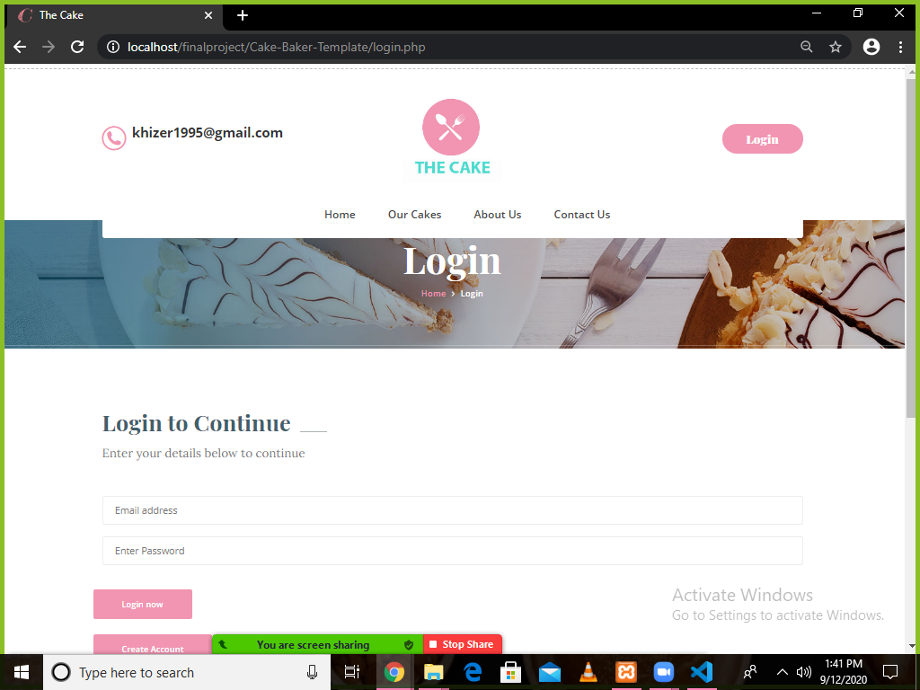

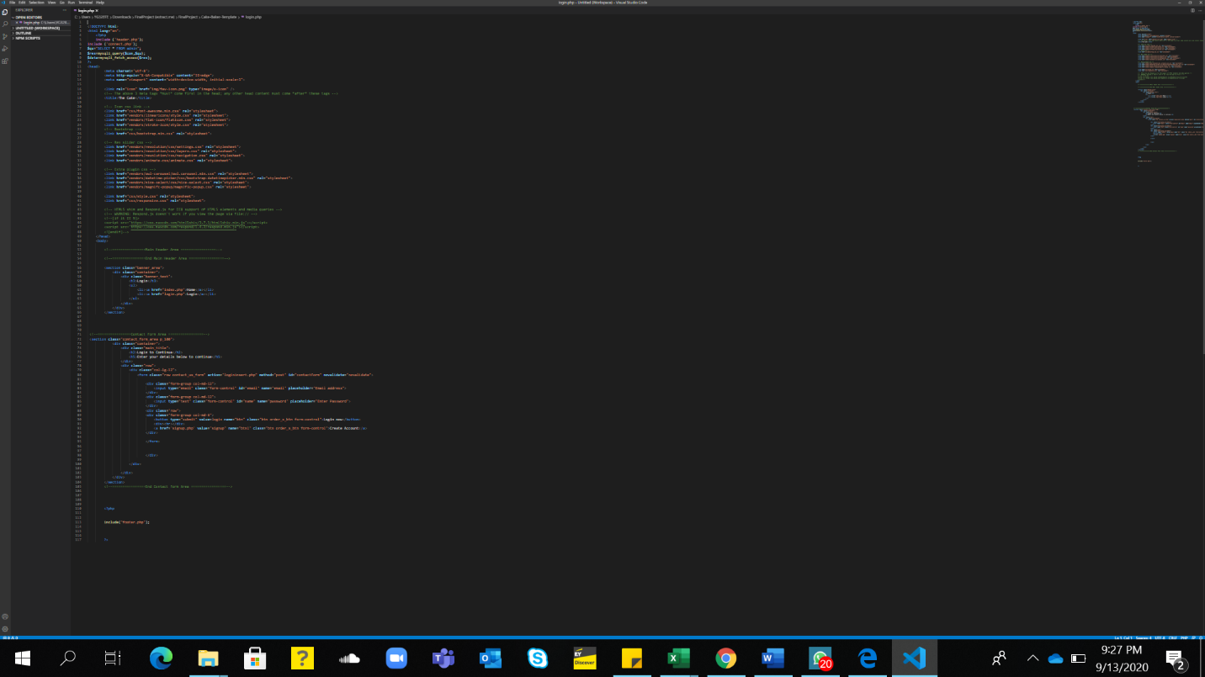

**SIGN UP PAGE**

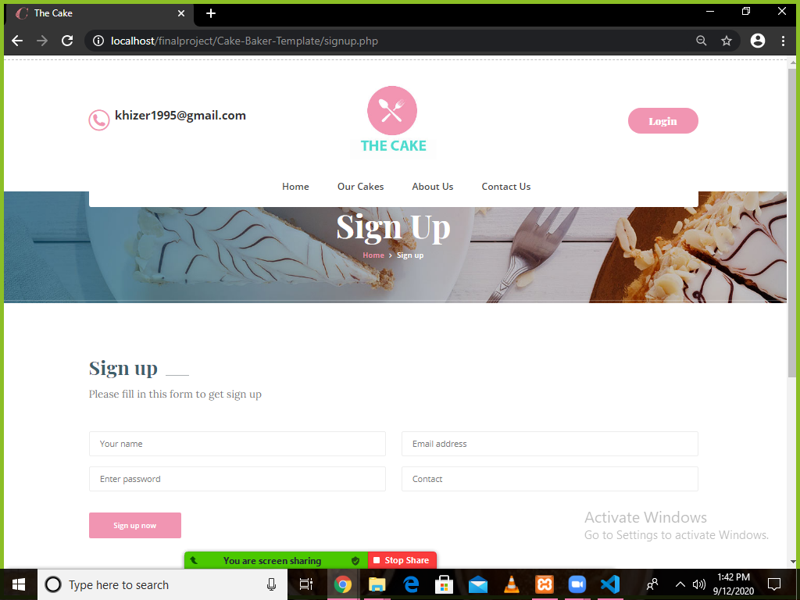

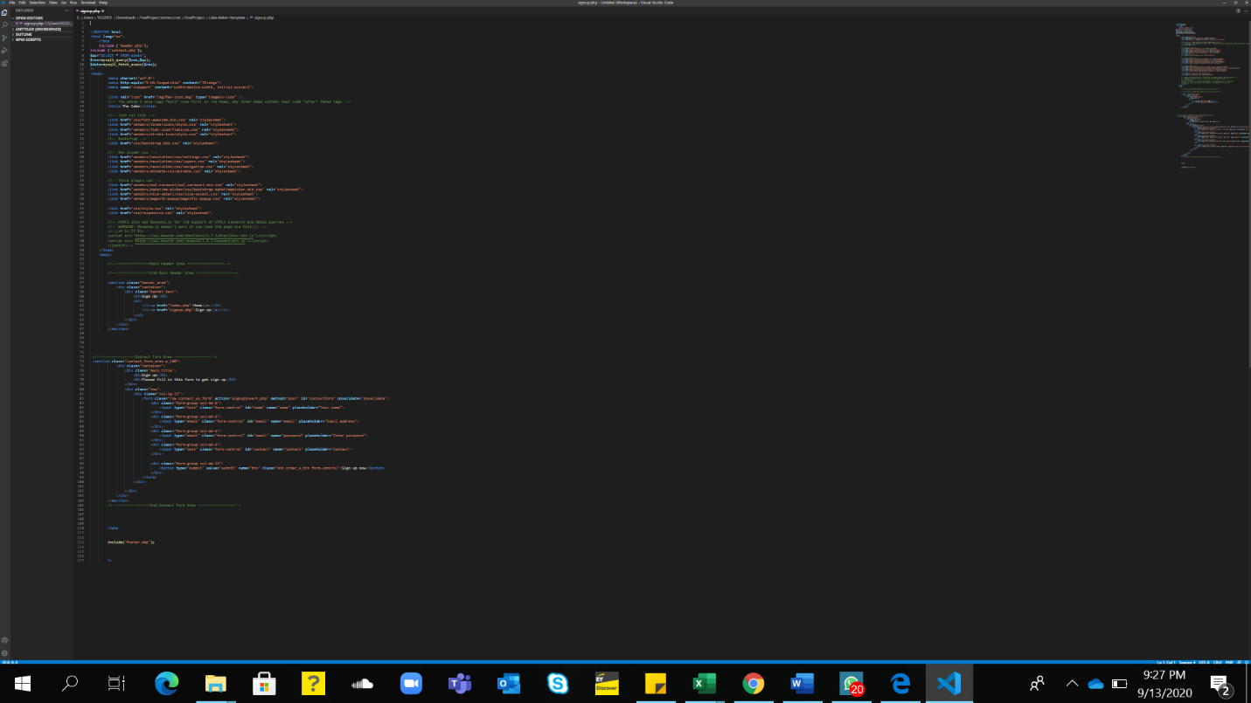



**CHAPTER 5**

**ADD TO CART**

**ADD TO CART PAGE**

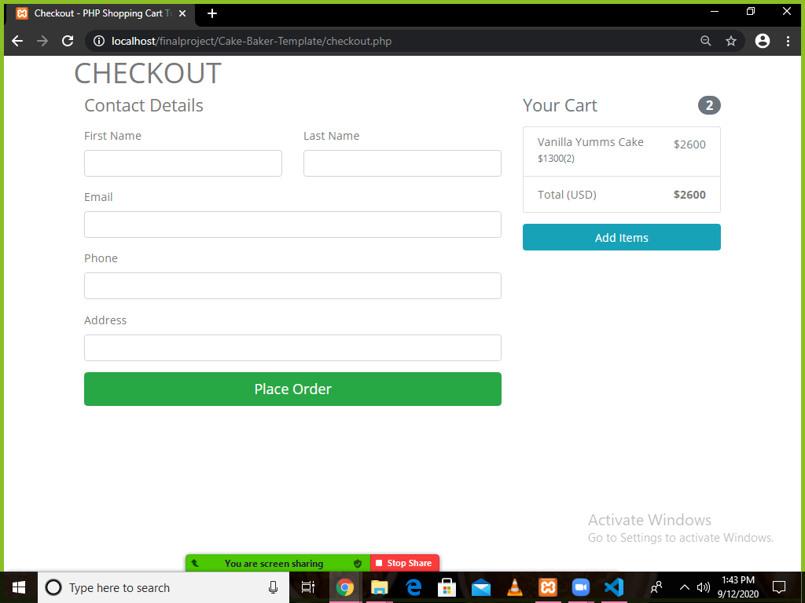

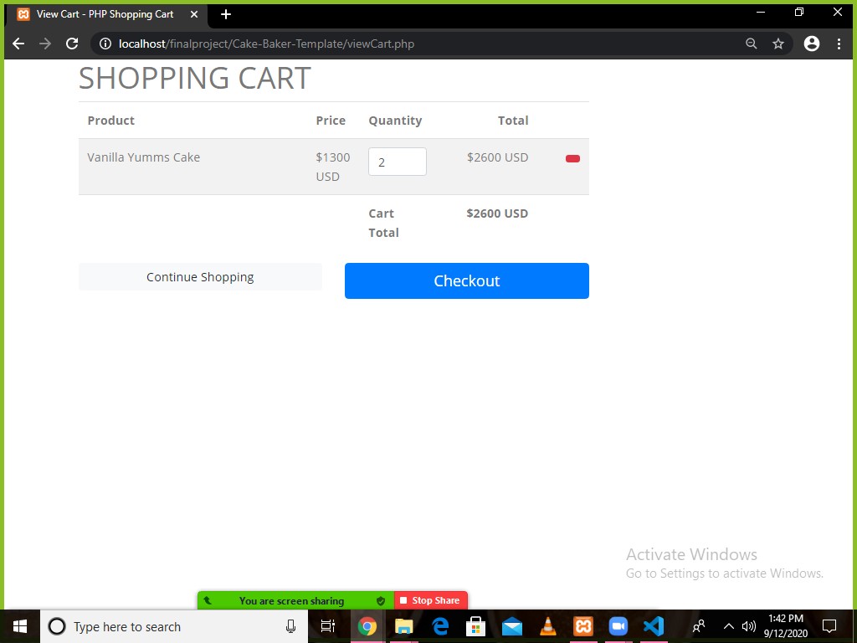

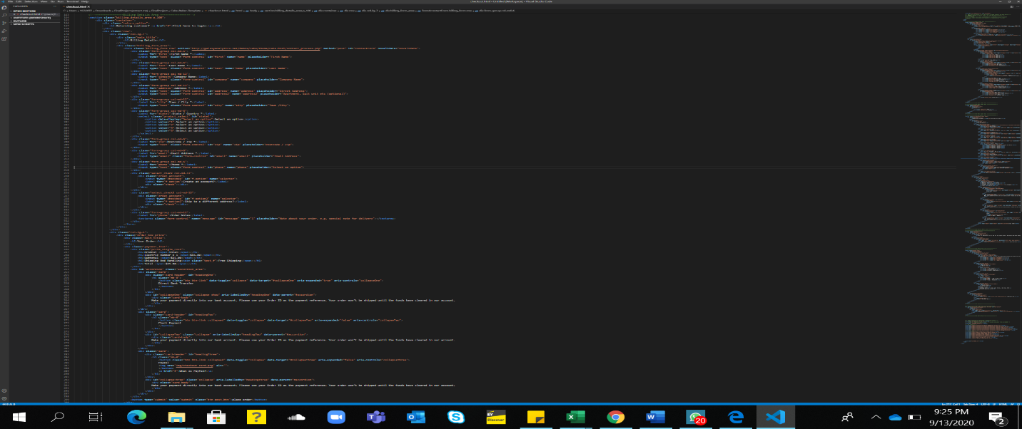



**CHAPTER 5**

**DASHBOARD**

**LAYOUT**

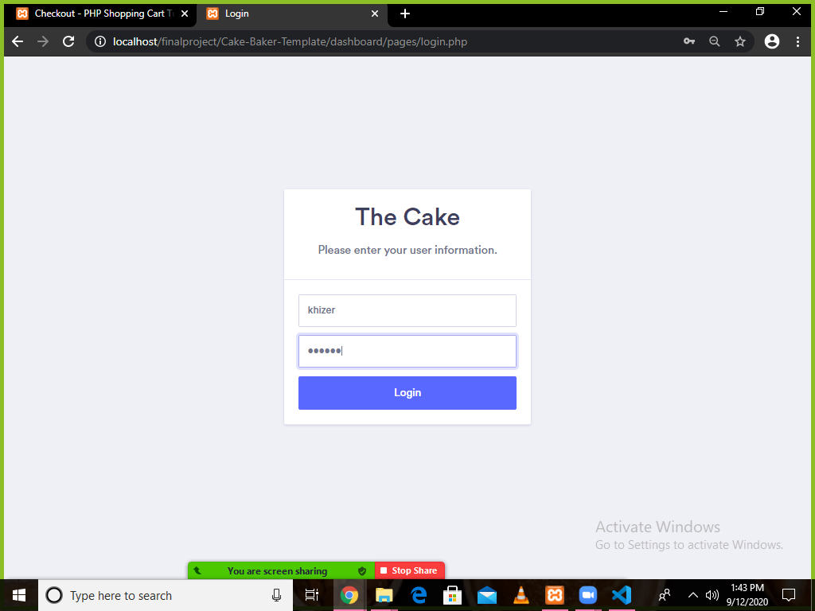

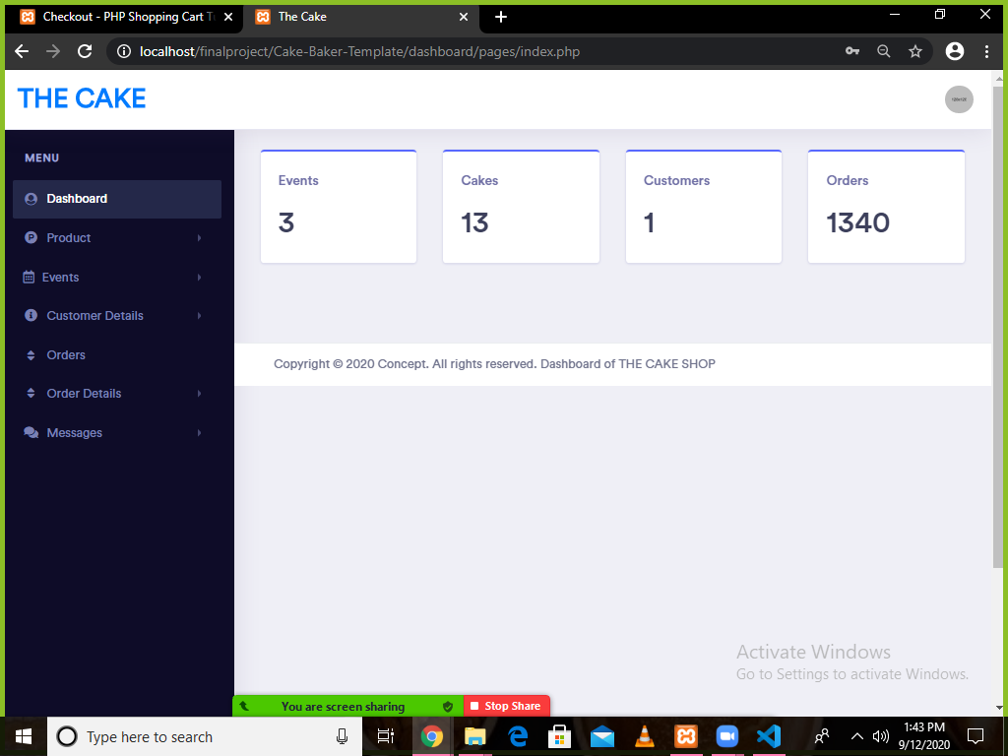

**PRODUCT SECTION**

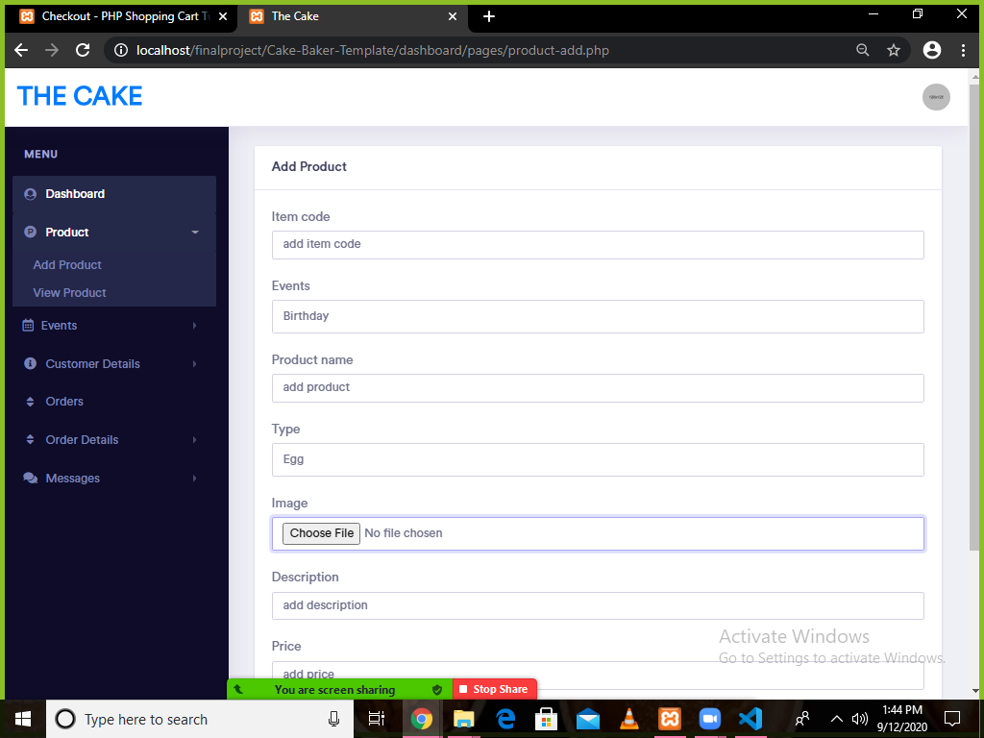

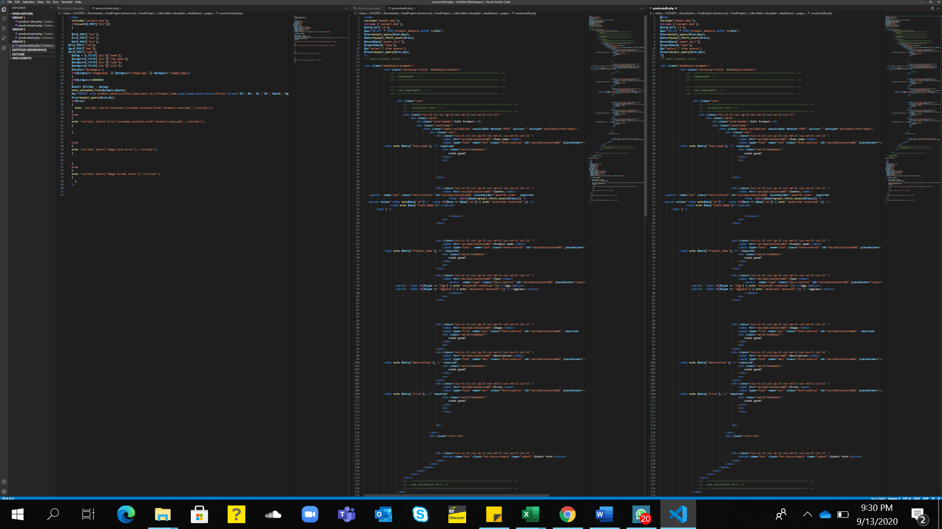

**EVENTS SECTION**

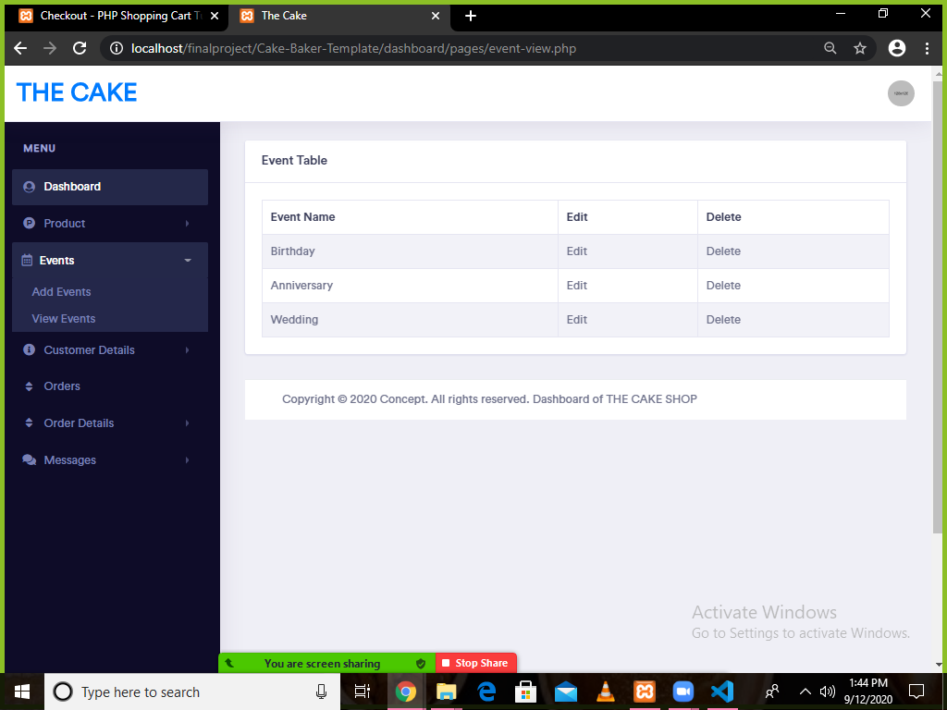

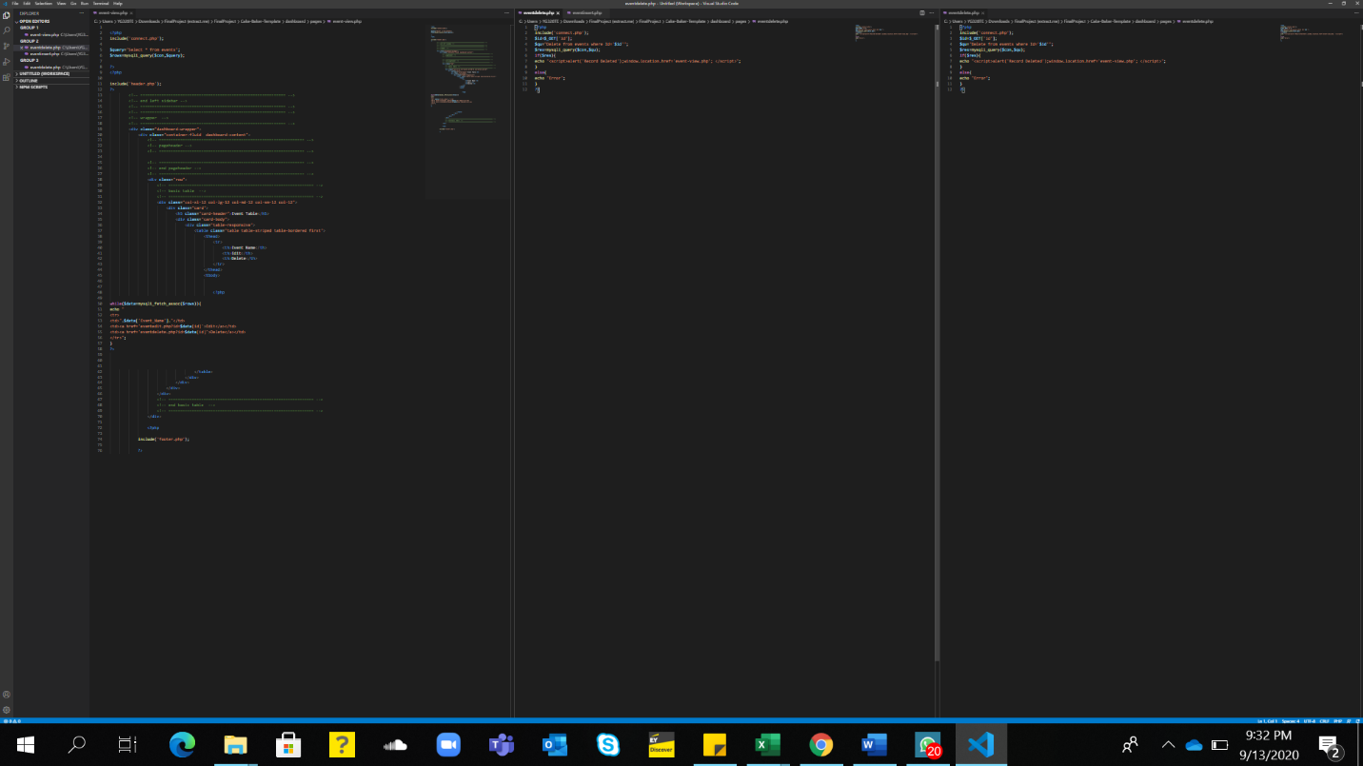

**CUSTOMER DETAILS**

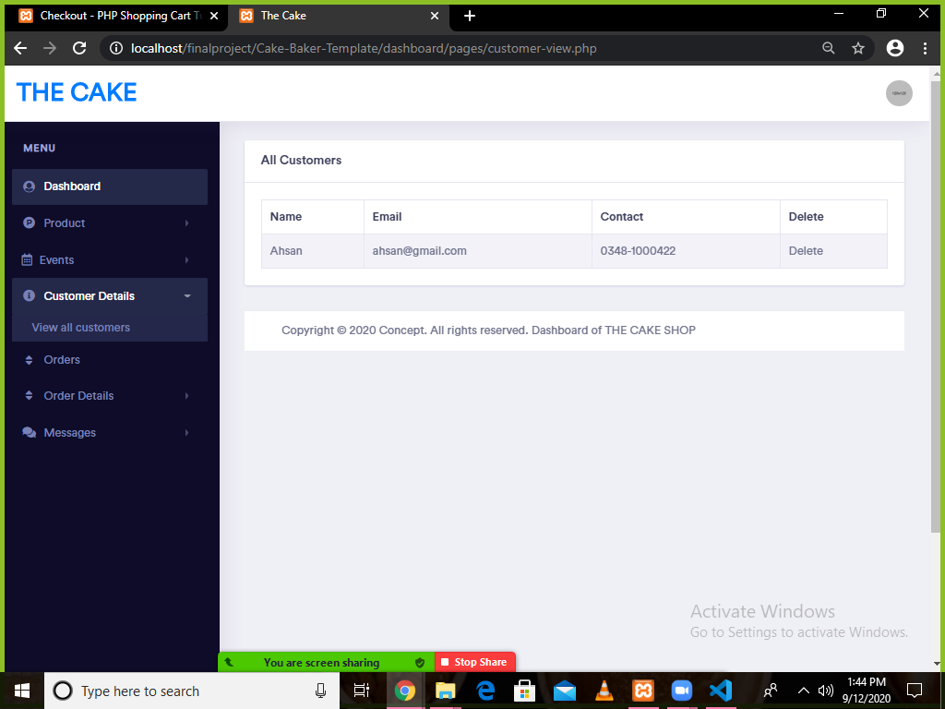



**MESSAGES**

